

1
Using EAN Geography Polygons (V1.1)

EAN Partner:Connect
Jon Arce

Overview

As part of EAN’s offerings to partners, we create and maintain a full set of relational files (34 in total), as well as custom scripts to automatically manage and update your local database file collection.

In this paper we focus on the Geography content of the files as per Expedia definitions of regions (just a Geography Destination). For Expedia a region is considered a “marketing region”, a bucket of hotels that represent a geography related search term, like cities, airports, landmarks and neighborhoods. Think of it like places people will search in order to find hotels located inside or close to it.

Technically those are defined as a polygon, in this white-paper we describe how to directly use the Polygons to query records using the SQL language, how to integrate other popular freely available polygon and points data, and how-to use it all in the popular MySQL relational database, as we will rely on the standardized Geo Spatial Extension, the queries could be easily adapted for other databases that support them.

Lets start by describing the relationship between the different Expedia regions.

EAN Regions

EAN define a region as a container, a simple 'bucket' that holds a collection of EANHotelIDs. Those 'buckets' are related to geography destinations, they are polygons that could be draw over a geography map and they could be of several types:
- Transportation – Airports, TrainStations, Ports of Sail, etc.
- Cities – Cities, Neighborhoods, Multi-City, Cities (and Vicinity),etc.
- Point Of Interest – stadiums, landmarks, beaches, monuments, etc.
So we will have a polygon for an AirportCode like JFK, a polygon for Hotels near the Statue of Liberty, another polygon of Hotels for 'North Manhattan' as well as a polygon for city of New York City. In that sense and hotel could belong to multiple polygons (regions).
Those regions defined by polygons are in reality 'Marketing Regions', they are NOT design to be geographically correct, they will actually change to reflect new hotels that are available, changes in weather seasons, high/low tourism seasons and even during special events (like the Olympics!). As an example, the region of Chicago, Illinois, USA will change to offer different inventory during winter vs. summer season.
In this document we will present all possible regions that we include the polygons and their hierarchical categories / subcategories, but most important, you will learn the required database queries to use them directly as a geospatial data.

MySQL Extensions for Spatial Data
The Open Geospatial Consortium (OGC) is is an international consortium of more than 250 companies, agencies, and universities participating in the development of publicly available conceptual solutions that can be useful with all kinds of applications that manage spatial data.
The Open Geospatial Consortium publishes the OpenGIS® Implementation Standard for Geographic information – Simple feature access – Part 2: SQL option, a document that proposes several conceptual ways for extending an SQL RDBMS to support spatial data. This specification is available from the OGC Web site at http://www.opengeospatial.org/standards/sfs.
Following the OGC specification, MySQL implements spatial extensions as a subset of the SQL with Geometry Types environment. This term refers to an SQL environment that has been extended with a set of geometry types. A geometry-valued SQL column is implemented as a column that has a geometry type. The specification describes a set of SQL geometry types, as well as functions on those types to create and analyze geometry values.
MySQL spatial extensions enable the generation, storage, and analysis of geographic features:
- Data types for representing spatial values
- Functions for manipulating spatial values
- Spatial indexing for improved access times to spatial columns

Converting Coordinates into Polygons
In the database downloadable content we have the following Coordinates data, some as Geo points (lat,long) others as full Polygons (a collection of lat,long):
- Users search for the 'RegionName'- probably your typical autocomplete listing.
- You resolve the 'RegionName' into a RegionID.
- From the RegionID you query for the list of HotelIDs.
- Now into the EAN API to get availability, using the getList method with the list of HotelIDs as <eanHotelList>.

EAN Regions (query for Multi-City(and vicinity))

For most mayor city markets, those that people all over the world know like: Paris, Las Vegas, Orlando, Miami, London, Tokyo, etc ….. Expedia utilize the powerful concept of CityName (and vicinity), this is a special geographic region that covers the best possible areas inside the city and close to it, that in our analysis, customer prefer when searching for that city name. The idea is to present a mix of classics and off-path trendy properties. This regions normally convert more revenue that the plain CityName areas. If you want to follow the Expedia model, when customers look for the CityName, show instead results for the CityName (and vicinity) instead.

In our previous example we used just the City of 'Las Vegas”, now let's look at the “Las Vegas (and vicinity)” region:
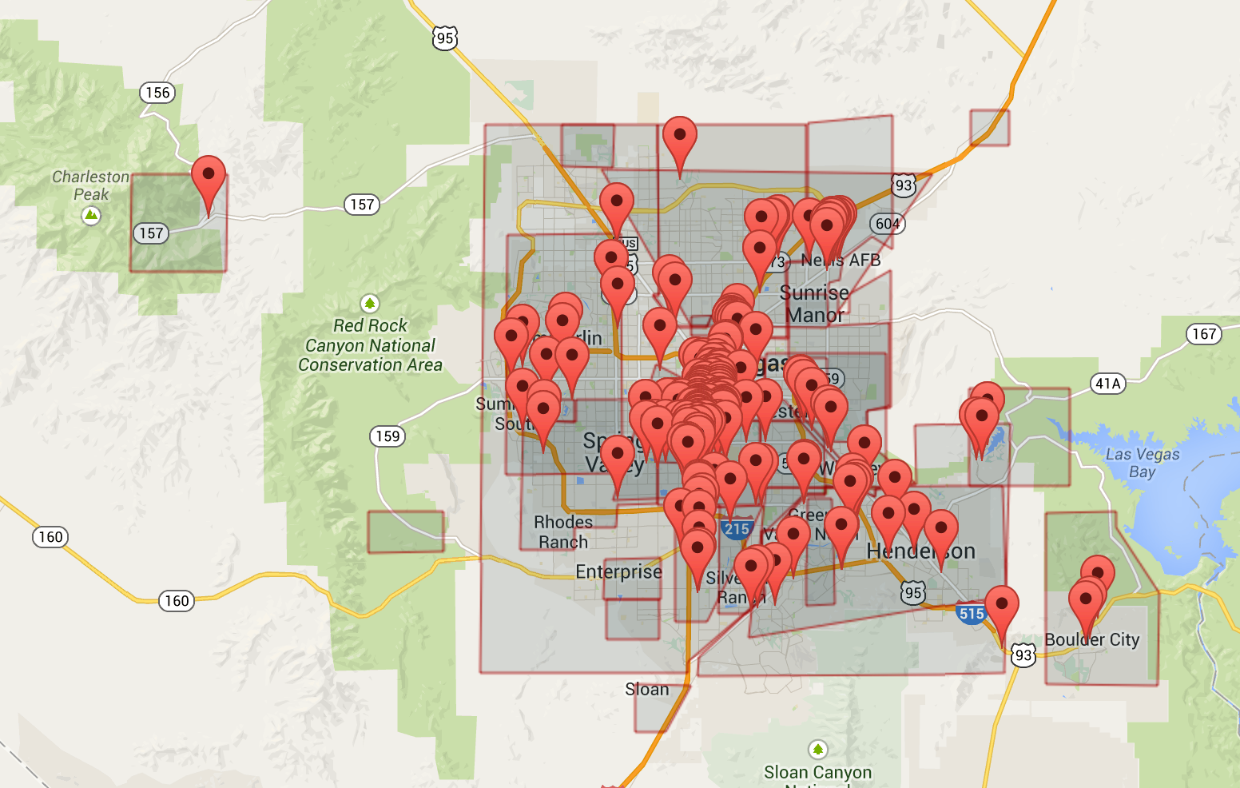

As you can see we cover a greater area, and possible that may not be desirable in all situations, it will be up to your particular integration to use or not use this type of area.

Query for Multi-City (Vicinity) (technical)

To get a list of CityName (and vicinity) from our database you will use once again the ParentRegionList table:
USE eanprod;
SELECT RegionID,RegionNameLong,RegionType,SubClass FROM parentregionlist
WHERE RegionType='Multi-City (Vicinity)' AND SubClass='';

With results:

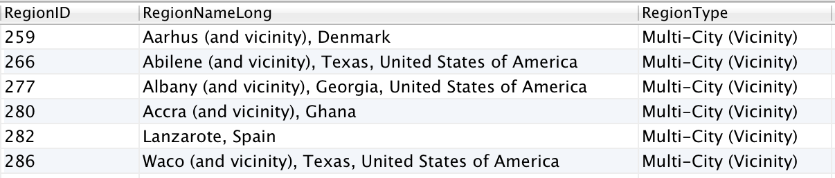

Notice that the (and vicinity) string is NOT always present in the results, we could use the created function of REGION_NAME_CLEAN to eliminate the (and vicinity) from the results strings.

If you need to filter by SubClass include it on the query, refer to the EAN RegionTypes/SubClasses section in this document for more information.

EAN Region (Neighborhood)

Neighborhood areas cover very specific regions that people tend to know and search for when traveling. These Neighborhood could be even as famous as the city, and maybe preferred over some less know cities. For example if you analyze the Expedia site, you will notice that for Las Vegas market, we present two options: “Las Vegas (and vicinity)” and “Las Vegas strip”. Lets look now at Neighborhood named “Las Vegas Strip” region:
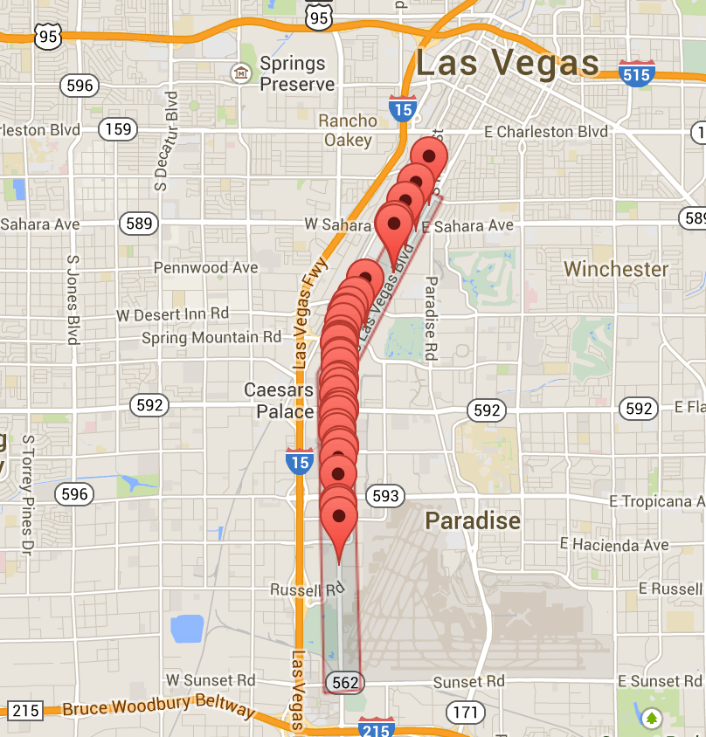

This is a collection of hotels that are on the stretch called “Las Vegas Strip”.

Query for Neighborhood (technical)

To get a list of Neighborhood from our database you will use once more the ParentRegionList table:
USE eanprod;
SELECT RegionID,RegionNameLong,RegionType,SubClass FROM parentregionlist
WHERE RegionType='Neighborhood' AND SubClass IN ('downtown','neighbor','regional');

With results:
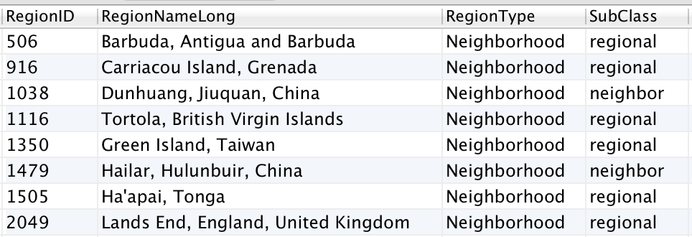

Notice that we use the SubClass to get only certain classes of data. Refer to the EAN RegionTypes/SubClasses section in this document for more information.

EAN Region (Airports)
Airports are a special type of regions as they are NOT an overlay map representation of a geography. If we follow once again the Las Vegas example, the most popular airport been “McCarren International Airport” we can see (or not see):

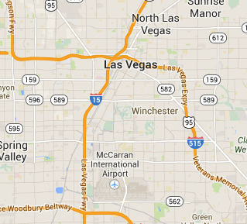

There is NO overlay for an Airport, the Airport are chosen by the hotel when we ask the question “What is the main airport that service your customers?”. In that sense an Airport region does not means properties that are close-by or surrounding the airport.

Query for Airports (technical)

To get a list of Airports we use the table AirportCoordinatesList, looking for LAS (the AirportCode is the IATA Code):
USE eanprod;
SELECT * FROM airportcoordinateslist WHERE AirportCode="LAS";

Results:

We can notice two ids present the AirportID and the MainCityID. We use the MainCityID and discover it is:

Basically the airports are preferred mapped into the MainCity (and Vicinity). This is the correct way of displaying results for the Airport, in this case there will be 219 hotels serviced by the LAS airport. Looking at a joined query with the ParentRegionList we got:

USE eanprod;
SELECT MainCityID AS 'RegionID',AirportName,RegionNameLong FROM airportcoordinateslist
JOIN parentregionlist ON airportcoordinateslist.MainCityID=parentregionlist.RegionID;

Results:
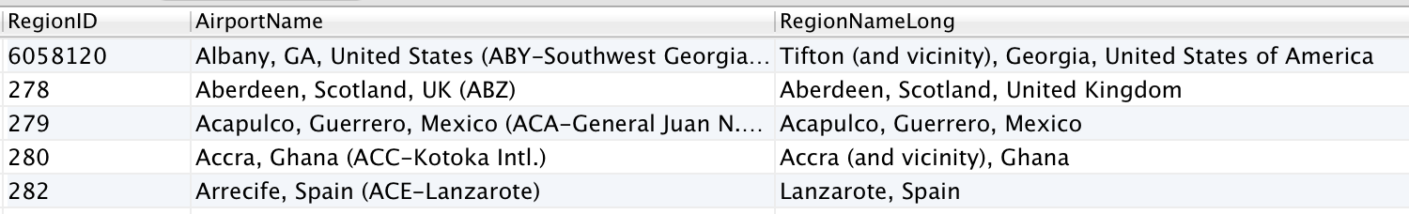

if we analyze this for cities where the airport is very far from the city center, like the case of London, you may prefer to find hotels near the airport, in those case you should use the Latitude and Longitude fields and either use the database stored procedure: sp_hotels_from_point or via the API using the getList by GPS point variation.

EAN (Point of Interest)
For the Point Of Interest we have the concept of Point Of Interest Shadow, it may sound misleading, but think of it as the “shadow that it's create in the surrounding area”, or simply as the area around the Point Of Interest. To be crystal clear, you will search for the “Shadow” RegionID and NOT for the Point Of Interest itself.

This “shadow” holds the RegionID that tell us the hotels that surrounds the POI. If we follow once again the Las Vegas example, let search for the traditional Welcome to Fabulous Las Vegas Sign:

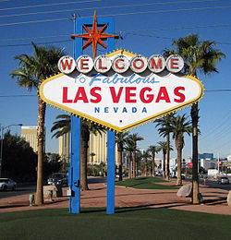
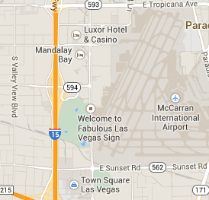

In the case of the sign it is considered a monument. We have some There are many SubClassifications like:

- anchor – Marinas and Ports (ex. Marina Del Rey, California) – 1507 records
- business – famous business building and locations (ex. Abbey Road Studios, London) – 75 records
- casino – Gambling places & casinos (ex. Golden Nugget Casino in Las Vegas) – 470 records
- civic – Cultural Centers, Halls, Convention Centers, Libraries (NYC Library, New York City) - 4038 records
- golf – Golf courses and Country Clubs (Pebble Beach Golf Course, California) – 4820 records
- historic – Villages, Ruins, Castles and similar (Royal Castle, Warsaw, Poland) – 6116 records
- icecream – funny name! But it covers Park, Zoo, Amusement Parks, Aquariums – think of children entertainments (but not limited to!) (Disney World, Orlando, Florida, USA) – 5222 records
- medical – famous old founded Hospitals, (KEM Hospital, Mumbai, India) – 954 records
- monument - famous monuments (Eiffel Tower, Paris, France) – 14401 records
- museums – Museums of all kinds (Bob Marley Museum, Kingston, Jamaica) – 12907 records
- schools – International Universities and Colleges (University of Zaragoza, Zaragoza, Spain) – 2853 records
- shopping – Shopping Malls, Districts and Streets (Bond Street, London, England) – 4194 records
- sign – Plazas, Squares and Signs (Welcome to Fabulous Las Vegas Nevada Sign) – 2452 records
- skiing – Ski Resort, Ski Lift, Ski Area (Furano Ski Area, Asahikawa, Japan) – 1808 records
- stadium – Stadiums, Bowl and Arenas (sport related) (San Siro Stadium, Milan, Italy) – 3719 records
- sunglass – Beaches (Ipanema Beach, Rio de Janeiro, Brazil) – 5053 records
- theater – Theaters, Opera (Komische Oper Berlin, Berlin, Germany) – 3455 records
- tree – Public Parks, Valleys, Lakes, Mountains (City Park, Biel, Switzerland) – 14305 records
- winery – Wineries (Karikari Estate Winery, Matauri Bay, New Zealand) - 1316

You can use the SubClassification to filter out the ones you need.

Query for POIs (technical)
To get a list of Points of Interest we prefer to use the PointOfInterestCoordinatesList, in this table we filter the SubClass on the field SubClassification, it also includes the Latitude and Longitude of the location that we could use to calculate the distance from the hotel (could use a Haversine formula or similar implementation), looking for all stadiums will be like:

USE eanprod;
SELECT * FROM pointsofinterestcoordinateslist WHERE SubClassification="stadium";

Results:
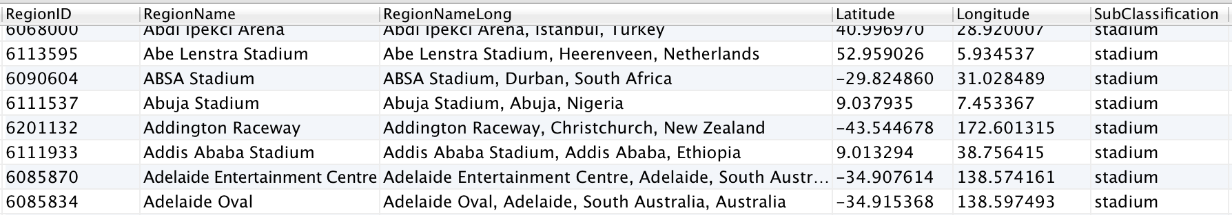
Notice that the RegionID we get from this query will be the same as its Point of Interest Shadow, from the ParentRegionList table.

Database helper functions
As part of our downloadable scripts, we do create the full structure of the eanprod database, but there are also some functions that will help managing the geographical tables and its data. Let's see what they can do.

Database Function (REGION_NAME_CLEAN)

This function allow use to eliminate anything that is inside parenthesis inside a string. We can use it to eliminate used eliminate things like '(type 7)' or '(and vicinity)' from the Region Names. As an example:

SELECT eanprod.REGION_NAME_CLEAN('Orlando (and vicinity)');

With the expected results of:

Orlando

We use it to clean up the names of the City (and vicinity) types, so it shows clean in the autocomplete list.

Other Geographic Tables
There are other geographical tables with variants of content that you may need for your integration. They are not consider main components but for completeness, lets list them with possible usages:

- AliasRegionList – list different spellings or names for the same region (however this table currently present Alias in different languages, but wrongly identified, so its use may be limited). There are localized versions for other languages of this table.
- CityCoordinatesList – for each region it list the geo-point that construct the polygon that defines the region. Useful if you need to illustrate over a region over a map.
- CountryList – list of all countries, with ISO country codes interesting if contains a transliteration of the name (non accented version). There are also localized versions of this table.
- NeighborhoodCoordinatesList – similar to CityCoordinatesList but for the Neighborhoods, it present the polygon that describe the area. Only useful if you want to display the region over a map. In the RegionName field you will find a “(type #)” the number are references to:
  - Neighborhood
  - Downtown/City Center
  - Secondary Cities – Cities close to bodies of water (Lake or Sea) however there are some very far, so please do not use as indicator of “near the water” (use the CityCoordinatesList instead)
  - Airport Vicinity
  - Regional names & others (like north, south, east, west), also covers Amusement Parks and others) (733 records)
  - Landmark / Place
  - Landmark / Beach
  - Train Station Vicinity
- RegionCenterCoordinatesList – Gives you the CenterLatitude and CenterLongitude geo-point of regions (excluding airports and Points of interests).

As you can see they will be mostly useful for mapping (over a map service) and for displaying or solving alternate names of the regions.

Conclusion

We have discussed the various geographical information and data tables that Expedia makes available to the partners community. All the scripts you see here are available at our github repository repository under the /Geography sub directory of the scripts section.

As we presented we cannot give you a simple geography file that will fit all scenarios, that very much will depend on the specifics of your market target. Let us know if you find this WhitePaper useful or if you need some more clarifications, or queries, please send us a note at: apihelp@expedia.com .

Till next time!

Jon C. Arce (jarce@ean.com)

